Project Name: Bunning Store – Berri SA | Date:April 16
Project No… DF/PD685 | Sheet 7 of 9

Inline Exhaust Fan
System: EF - 03
Location: Timber Trade Sales
Tested By: Scott Mcgahey
Witnessed Josh Edwards

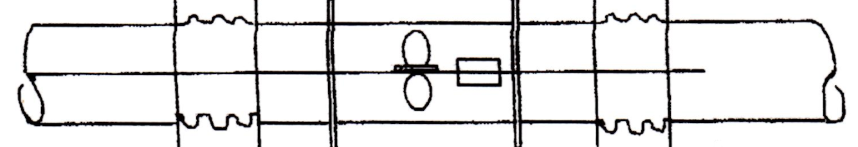

IN-LINE FAN – DIRECT DRIVE

Make Fantech
Model AP0806GP6/31
Rated kW 2.42KW
Speed 16 R/S
FLC/ Start (A): 5.72/32.76
Voltage: 415V – 3 Phase

Specified Duty: 5400L/S (900L/S per 1000 x 600 grille)

Air Flow Results 53 886
54 891
55 906
56 912
57 902
58 907
5404

